AMR Surveillance Analysis
SPIDAAR, Acinetobacter, and GEARS Datasets — Resistance Findings (Draft)
Prepared by Winifred Chukwuma | AMR ID: 00013425 | Vivli AMR Register Data Challenge

1. Overview
This report summarizes an exploratory resistance analysis of the SPIDAAR isolate dataset (244 bacterial isolates from hospitalized patients across four African countries: Kenya, Ghana, Uganda, and Malawi). The analysis follows the step-by-step workflow provided by the project lead: understand the data, clean it, explore it, analyze resistance patterns, look for trends, compare groups, identify hotspots, and visualize results.
This draft now also includes the Acinetobacter surveillance dataset (EUCAST breakpoints, Section 8) and a supplementary section on a third global surveillance dataset (GEARS, Section 9).
Per the project's methodological framework, chi-square tests of independence were applied to the key comparisons in this report (country, infection type, and year) to confirm whether observed differences are statistically real rather than due to chance. Results are noted alongside each relevant finding.

2. Dataset Summary
Item | Detail
Total isolates | 244
Countries | Kenya (107), Ghana (75), Uganda (52), Malawi (10)
Collection period | Mostly 2022 (221 isolates); 22 from 2021 — single-year snapshot
Most common bacteria group | Enterobacterales (136 isolates, 56%)
Data completeness | Largely complete; 1 missing sample date, 9 missing amrtx values

3. Overall Resistance Levels
Resistance measure | Yes | No | Unknown
MDR (multidrug resistant) | 73.8% | 20.9% | 5.3%
3GC-R (3rd-gen cephalosporin resistant) | 74.2% | 9.4% | 16.4%
MRSA (among 14 S. aureus isolates) | 64.3% | 35.7% | —

4. Resistance by Bacteria Group
Multidrug resistance (MDR) rate by bacteria group, among isolates with a known result:
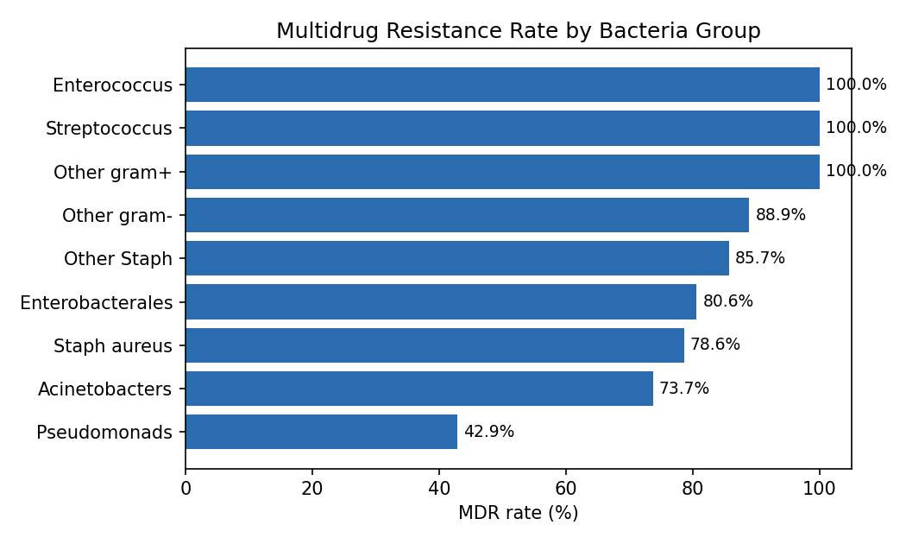

5. Resistance by Country
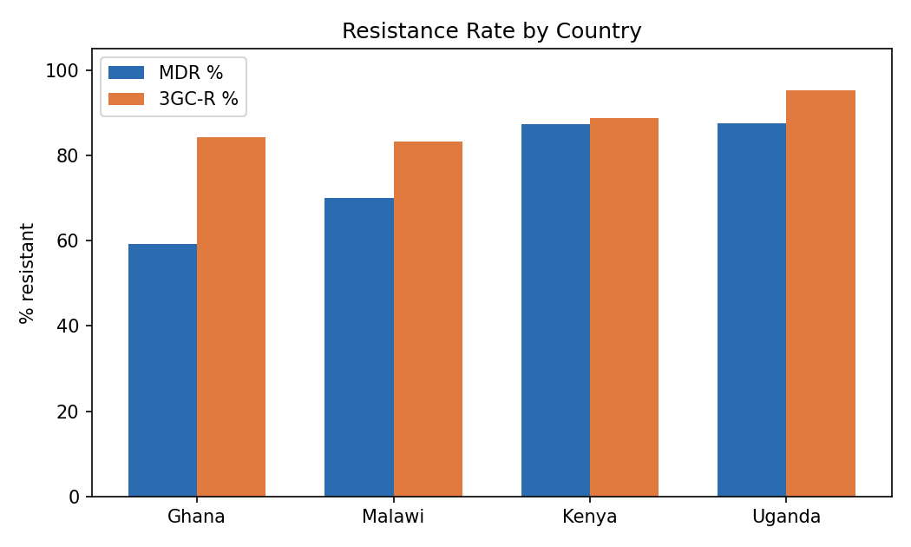
Uganda and Kenya show consistently higher resistance than Ghana, both overall and within Enterobacterales specifically (Uganda 94%, Kenya 84%, Ghana 70%), suggesting the gap reflects real regional differences rather than differences in which bacteria were sampled.
Statistical note: a chi-square test confirms this country-level difference is statistically significant (chi2=22.62, p<0.0001) - this is a real pattern, not chance.

6. Resistance by Infection Type
Infection type | Isolates (known result) | MDR rate
cIAI (intra-abdominal) | 62 | 83.9%
HAP (hospital-acquired pneumonia) | 70 | 80.0%
cUTI (urinary tract) | 31 | 74.2%
cSSTI (skin/soft tissue) | 50 | 72.0%
Statistical note: a chi-square test found this difference is NOT statistically significant (p=0.52). With these sample sizes, we cannot confidently conclude that infection type actually drives different resistance rates - the apparent spread above could be due to chance.

7. Hotspots
- Highest-burden combination: Uganda + cIAI/HAP infections + Enterobacterales.
- The isolate dataset records only aggregate resistance flags (MDR, 3GC-R, MRSA), not per-antibiotic results — so a full MDR/XDR/PDR drug-count profile could not be built from this file alone.

8. Acinetobacter Surveillance Data (EUCAST Breakpoints)
The IST-Entasis Acinetobacter dataset (5,032 isolates, 2016-2021, global) was classified using official EUCAST v14.0 (2024) clinical breakpoints, as confirmed by the project lead. Five of the ten antibiotics tested have a published EUCAST breakpoint for Acinetobacter spp.:
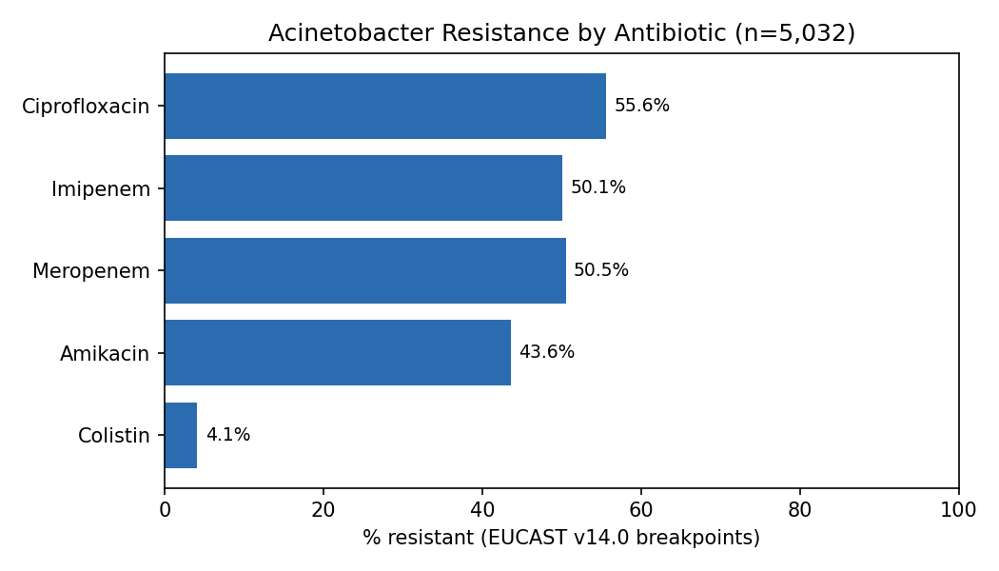
Colistin resistance is notably low (4.1%) and stable across 2016-2021 - meaningful because it is typically a last-resort drug for this organism. Meropenem, imipenem, and colistin resistance show no clear year-over-year worsening trend across the period (fluctuating within a ~47-56%, ~47-56%, and ~2-6% band respectively).
Four antibiotics (Cefepime, Minocycline, Tigecycline, and Sulbactam/Sulbactam+514) could not be classified: EUCAST v14.0 has no published breakpoint for Cefepime, Minocycline, or Tigecycline against Acinetobacter (a newer 2025 EUCAST update reportedly adds these, but exact figures were not confirmed from a reliable source), and no EUCAST breakpoint exists for Sulbactam against Acinetobacter at all, standalone or combined.

9. GEARS Dataset (Venatorx) - Supplementary Findings
A third, much larger surveillance dataset (29,365 isolates, 2018-2022, 7 world regions) was reviewed per the project lead's request. It contains no Acinetobacter isolates, so it cannot be merged with the datasets above; it is presented here as a standalone supplementary section covering different organisms - predominantly Pseudomonas aeruginosa, E. coli, and Klebsiella pneumoniae.
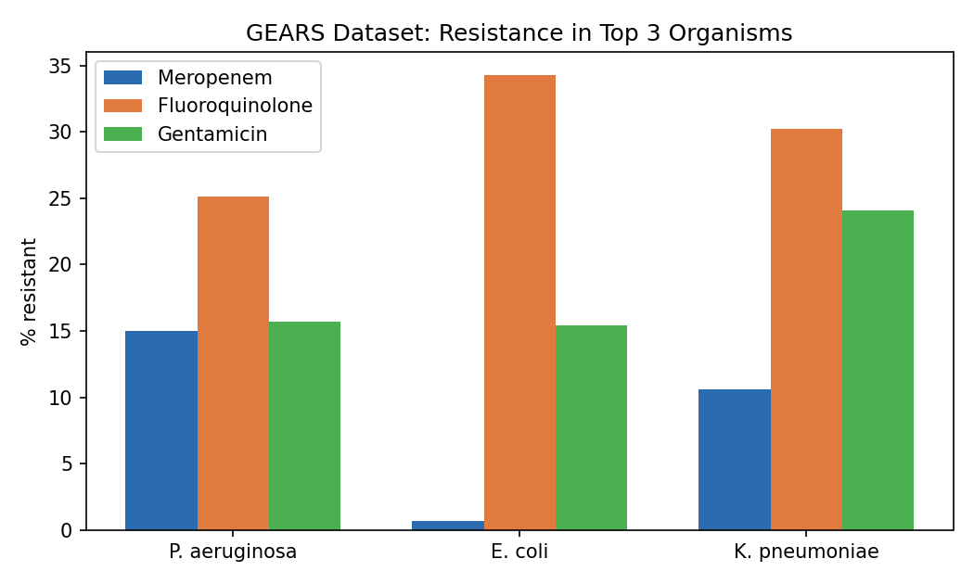
- E. coli meropenem resistance is very low (0.7%) - carbapenems remain highly effective against it in this dataset, a sharp contrast to the 50%+ carbapenem resistance seen in Acinetobacter.
- Fluoroquinolone resistance is substantial across all three organisms (25-34%); E. coli and K. pneumoniae were tested with levofloxacin rather than ciprofloxacin in this dataset.
- Pseudomonas aeruginosa meropenem resistance shows no clear upward trend across 2018-2022 (ranging 12-19% year to year).

10. Resistance Trends by Year
Acinetobacter dataset (2016-2021): 2016 stands out as the peak year, with the highest resistance for 4 of the 5 classifiable antibiotics. Resistance was highest at the start of the surveillance period and dipped afterward, rather than climbing over time.
Antibiotic | Highest year | Rate
Ciprofloxacin | 2016 | 64.1%
Imipenem | 2016 | 56.3%
Meropenem | 2016 | 54.2%
Amikacin | 2016 | 47.7%
Colistin | 2020 | 5.7%
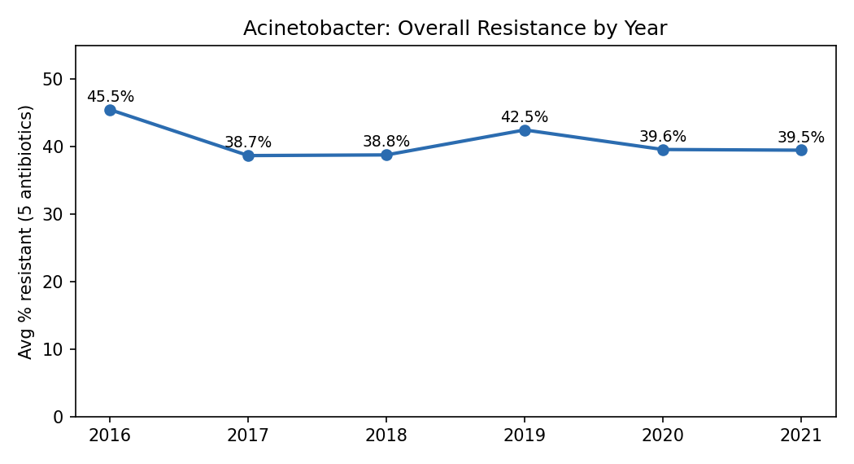
GEARS dataset (2018-2022): no single dominant year across organisms - Pseudomonas aeruginosa peaked in 2021 (19.1%), Klebsiella pneumoniae peaked in 2019 (12.5%), and E. coli stayed consistently low throughout, peaking only slightly in 2022 (1.4%).
SPIDAAR dataset: not meaningful to compare by year - 221 of 244 isolates were collected in 2022 alone, with only 22 from 2021.
Statistical note: chi-square tests confirm the year-to-year variation is statistically significant for all 5 classifiable Acinetobacter antibiotics (p<0.05 in every case) and for GEARS P. aeruginosa meropenem (p<0.0001) - these year patterns are real, not random fluctuation.

11. Patient-Level Resistance by Age, Sex, and Ward
No direct ID links the isolate file to the patient file, so this comparison uses the patient file's own built-in resistance summary field (amrp: drug susceptibility result at patient level) rather than attempting an unreliable approximate match between the two files.
Group | Resistant % | Statistical significance
Sex (3 codes) | 84.4% - 88.9% | Not significant (p=0.89)
Ward (4 wards) | 85.0% - 85.7% | Not significant (p=0.9997)
Age group (14 codes) | 25% - 100% | Not significant (p=0.09); many groups have under 10 patients
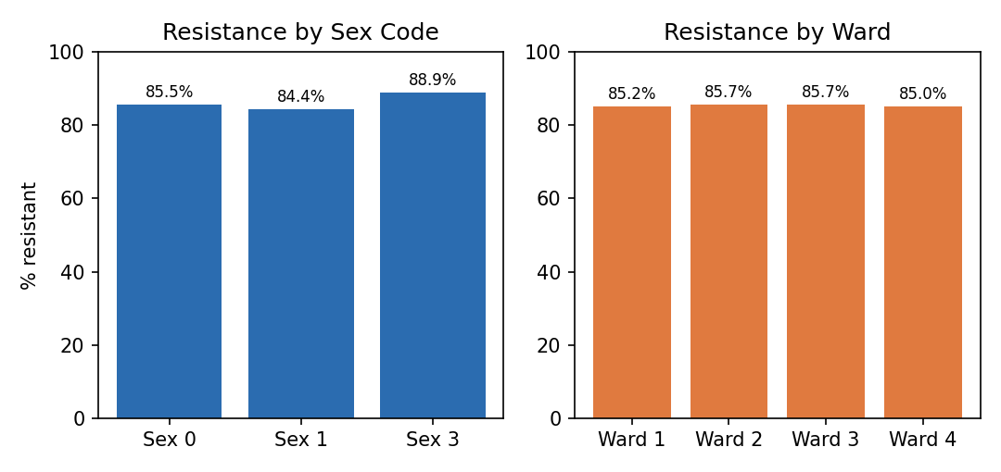
None of the three comparisons reach statistical significance. Sex and ward show almost no difference in resistance. Age group shows more visible spread, but most age groups have very small sample sizes (as few as 4-9 patients), so this is not a reliable pattern.
Note: the codebook does not define what the numeric codes for age group and sex correspond to (e.g., actual age ranges, or which code is male/female) - results are reported using the raw codes pending that clarification.

12. Research Questions Addressed
Mapping findings back to the three research questions from the project proposal (AMR ID: 00013425):
Q1: How can hidden patterns within surveillance datasets be decoded to enable early detection and prediction of high-risk phenotypes across critical pathogens?
- Uganda + cIAI/HAP infections + Enterobacterales is a confirmed, statistically significant hotspot in SPIDAAR (p<0.0001).
- Acinetobacter carbapenem resistance (imipenem/meropenem, ~50%) and near-zero colistin resistance (4.1%) are the clearest high-risk/low-risk phenotype signals found.
Q2: How can global surveillance data be leveraged to identify emerging MDR/PDR threats and generate predictive insights guiding stewardship?
- No dataset showed a rising MDR trend over time; Acinetobacter resistance was actually highest at the start of surveillance (2016) and has not climbed since - an important, counter-intuitive finding for stewardship framing.
- Formal predictive modeling (forecasting future resistance) was not performed in this draft - flagged in Next Steps.
Q3: How can advanced analysis of AMR surveillance data provide real-time detection, characterization and prediction of resistance patterns among critical-priority pathogens, enabling targeted stewardship interventions?
- Characterization was completed across three datasets (SPIDAAR, Acinetobacter, GEARS) covering multiple ESKAPE-relevant organisms, with statistically validated comparisons by country, year, and (for SPIDAAR) patient demographics.
- Real-time/predictive components remain future work; this draft is a descriptive and comparative foundation for that next phase.

13. Recommendations
- Prioritize stewardship interventions in Uganda and Kenya, and specifically for cIAI/HAP infections, where resistance burden is confirmed statistically highest.
- Preserve colistin as a reliable last-resort option for Acinetobacter infections - resistance remains low (4.1%) and stable, unlike carbapenems (~50%).
- Do not assume resistance is worsening over time based on this data - the clearest year-over-year pattern (Acinetobacter) shows the opposite: resistance was highest in 2016 and has not trended upward since.
- Treat E. coli carbapenem therapy as still highly reliable (0.7% resistant in GEARS) while treating Acinetobacter carbapenem therapy with much more caution (~50% resistant) - the two should not be managed the same way.
- Resolve the three open data items before finalizing: 2025 EUCAST breakpoints for cefepime/minocycline/tigecycline, age/sex code definitions for the patient file, and whether Projects.csv belongs in this deliverable.

16. Conclusion
Detecting high-risk regions: Supported. Uganda and Kenya show statistically significant higher resistance than Ghana (p<0.0001), concentrated in cIAI/HAP infections and Enterobacterales.
Detecting antibiotics losing effectiveness: Supported. Colistin remains reliable for Acinetobacter (4.1% resistant); carbapenems (imipenem, meropenem) and ciprofloxacin do not (~50-56% resistant). E. coli carbapenem resistance remains very low (0.7%) by contrast.
Detecting high-risk patient groups (age/sex/ward): Not supported by this data. None of the three comparisons reached statistical significance - reported honestly rather than overstated, pending clearer age/sex code definitions.
Detecting high-risk infection types: Not supported by this data. The apparent spread across cIAI/HAP/cUTI/cSSTI was not statistically significant (p=0.52) given current sample sizes.
Overall: this analysis gives clear, statistically-grounded direction on where (region) and what (antibiotic) stewardship should prioritize, while flagging that patient-group and infection-type targeting would need a larger sample before being recommended with confidence.

17. Limitations
- SPIDAAR: nearly all isolates were collected within a single year (2022), so no genuine year-over-year trend could be assessed from that dataset.
- SPIDAAR: Malawi's sample size (n=10) is small; its resistance rate should be interpreted cautiously.
- Acinetobacter: four of ten antibiotics could not be classified due to missing or unconfirmed EUCAST breakpoints (see Section 8).
- GEARS: heavily weighted toward Europe and North America, and cannot be directly compared to the Acinetobacter/SPIDAAR datasets since it covers different organisms.

